

DXC RealTime Projects

AZ-900, DP - 203



**June 10, 2022**

**DXC TECHNOLOGY PVT.LTD.**

Name: Aakriti Singh

Reg No: DXC262AB12002

**Project1 Name: Smart Vehicles**

Date: 10 June,2022

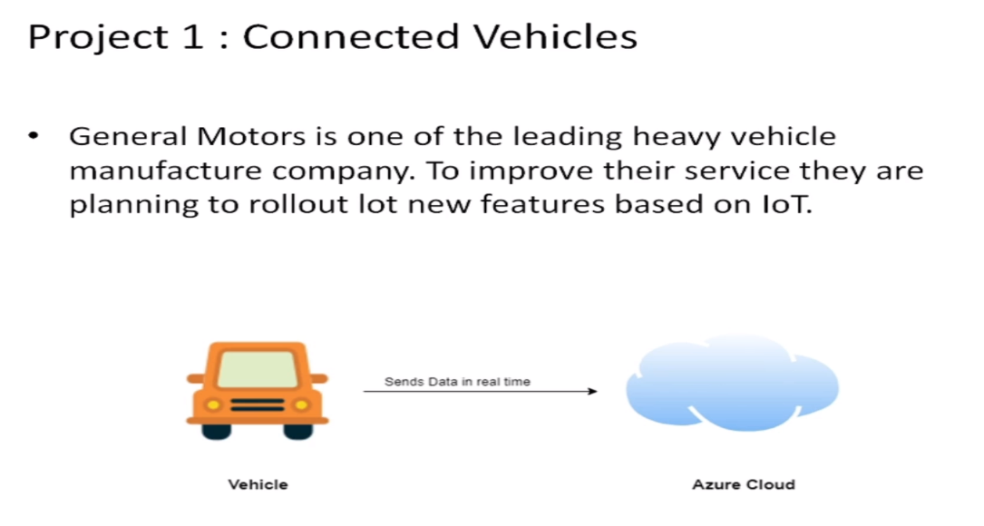

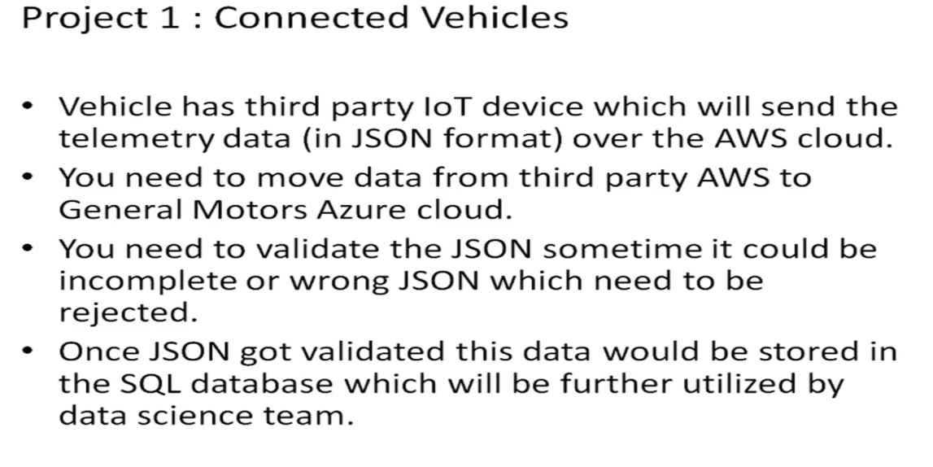

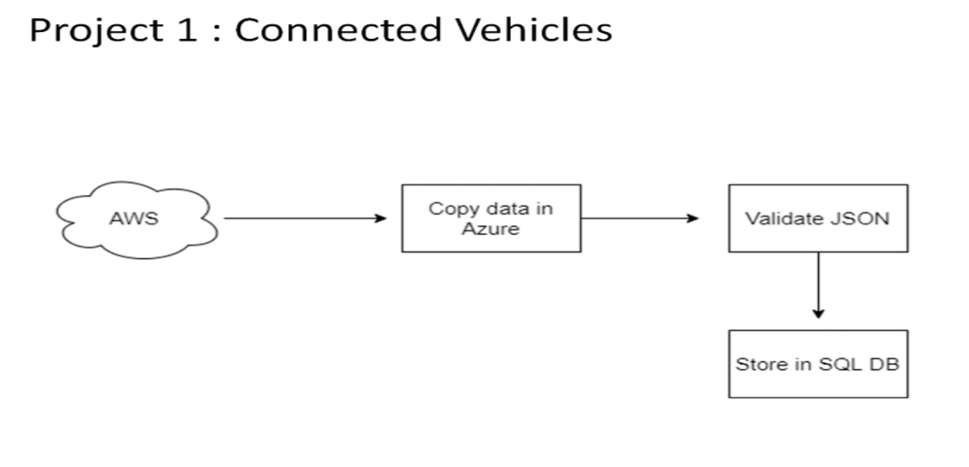

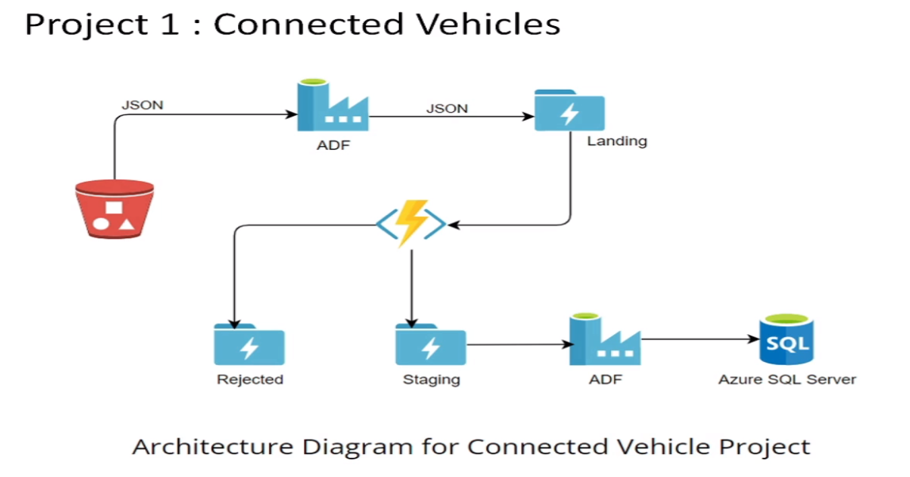

STEPS TO CREATE THE FOLLOWING ARCHITECTURE:

STEP-1

Login into the Azure Lab through your credentials. The screen should appear like this :

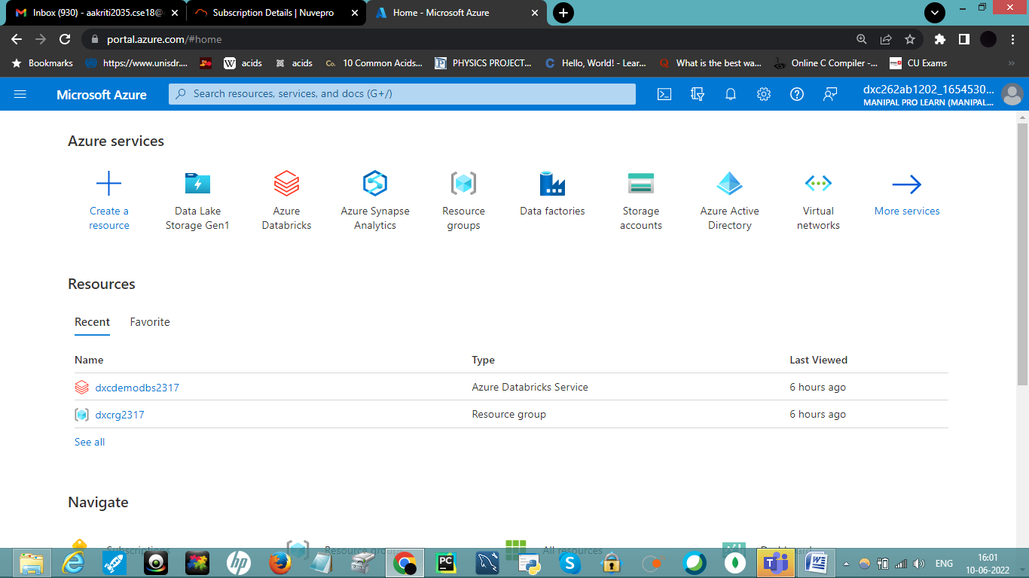

STEP-2

Click on Azure Data Factory icon or search for it in the search bar. After this a screen will appear like this :

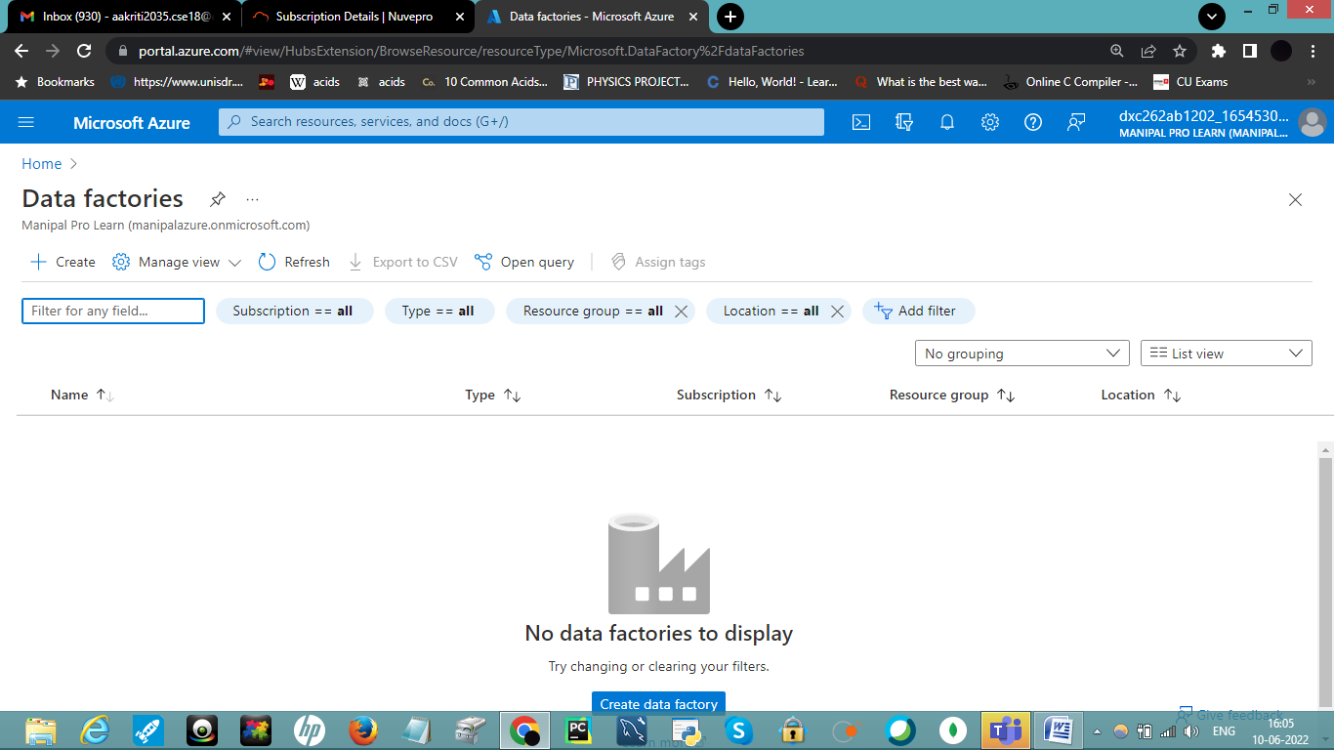

Click on + Create option , then fill the necessary data and click on Review+Create.

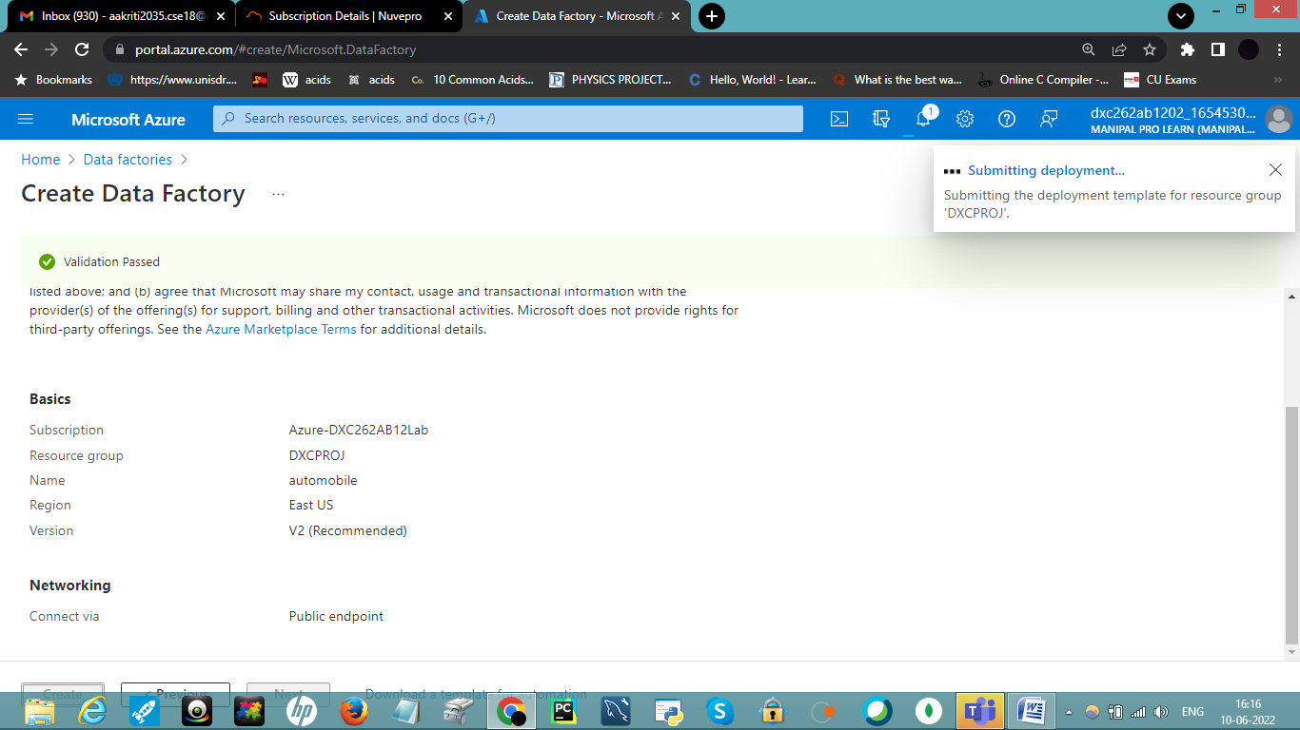

STEP-3

The Deployment will begin. After completion , click on Go to Resource Group. The main page will appear.

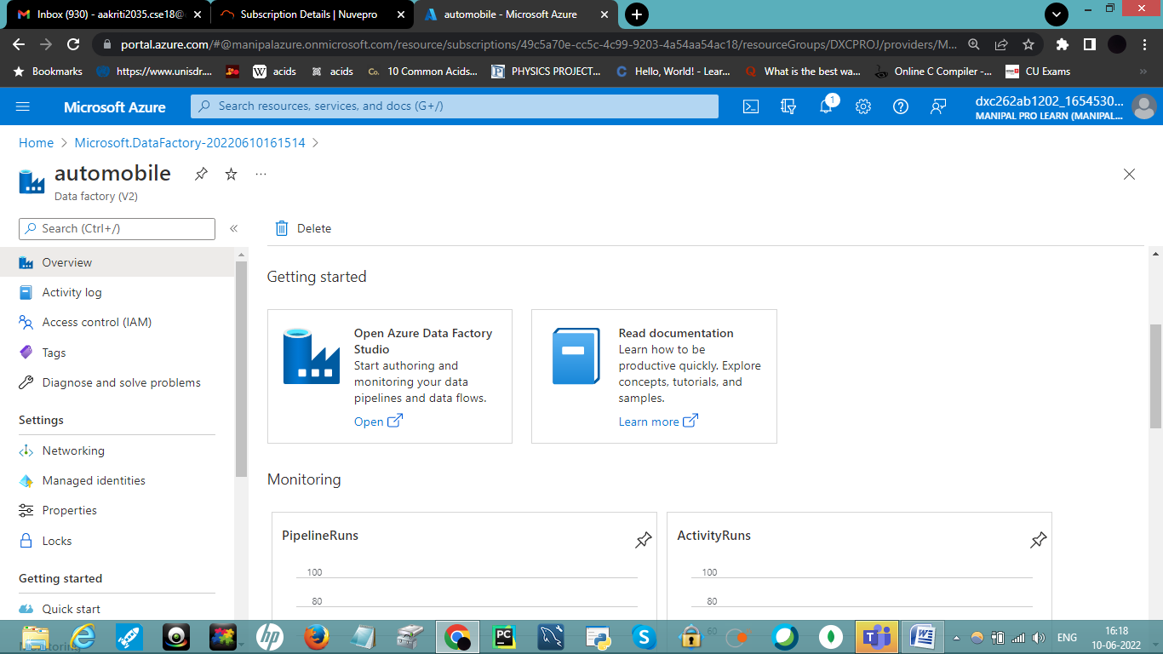

Click on Open Azure Data Factory. Following page will appear :

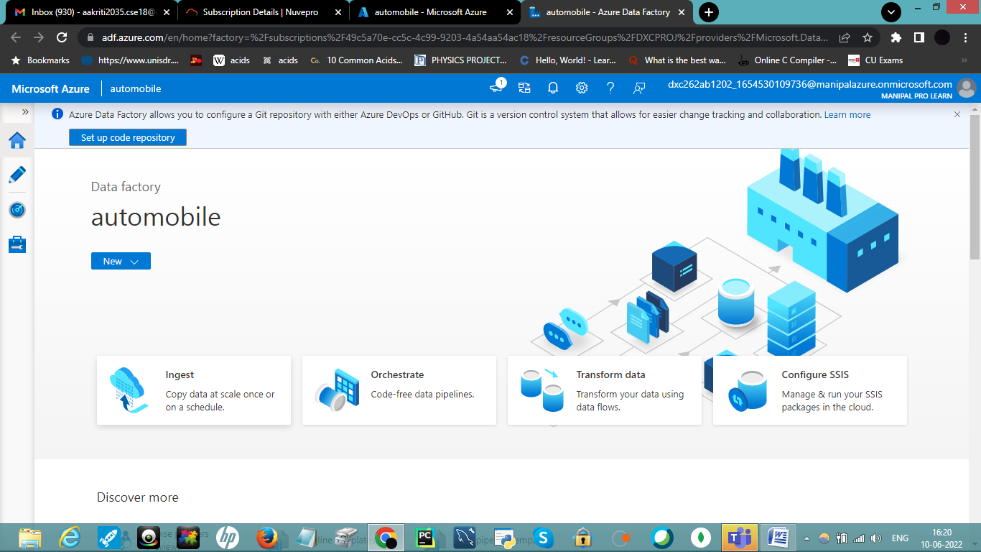

STEP-4

Go to Home Page of Azure , search storage accounts. Click on Storage Account. Click on Create.

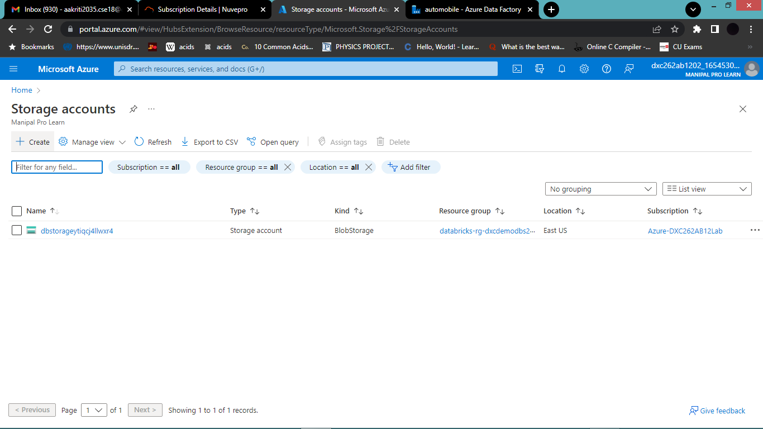

Complete all the configurations and click on Review+Create. Deploy it :

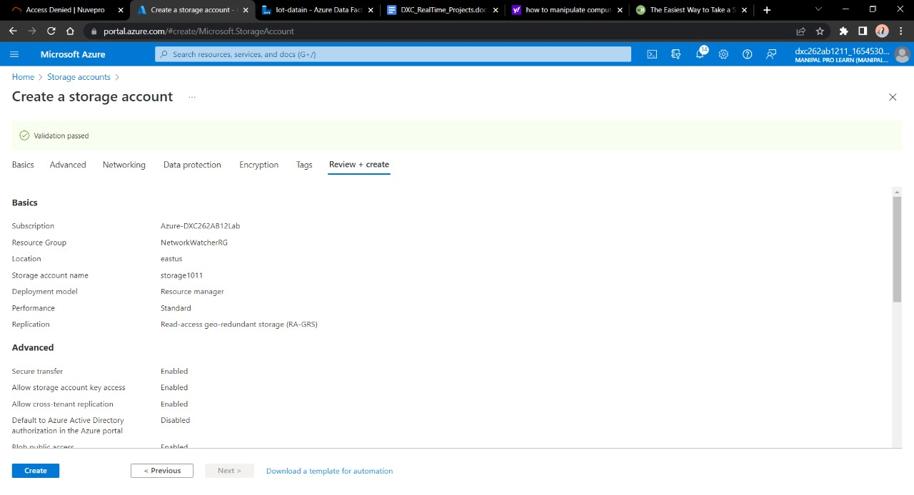

Once deployment is done click on Resource Group.

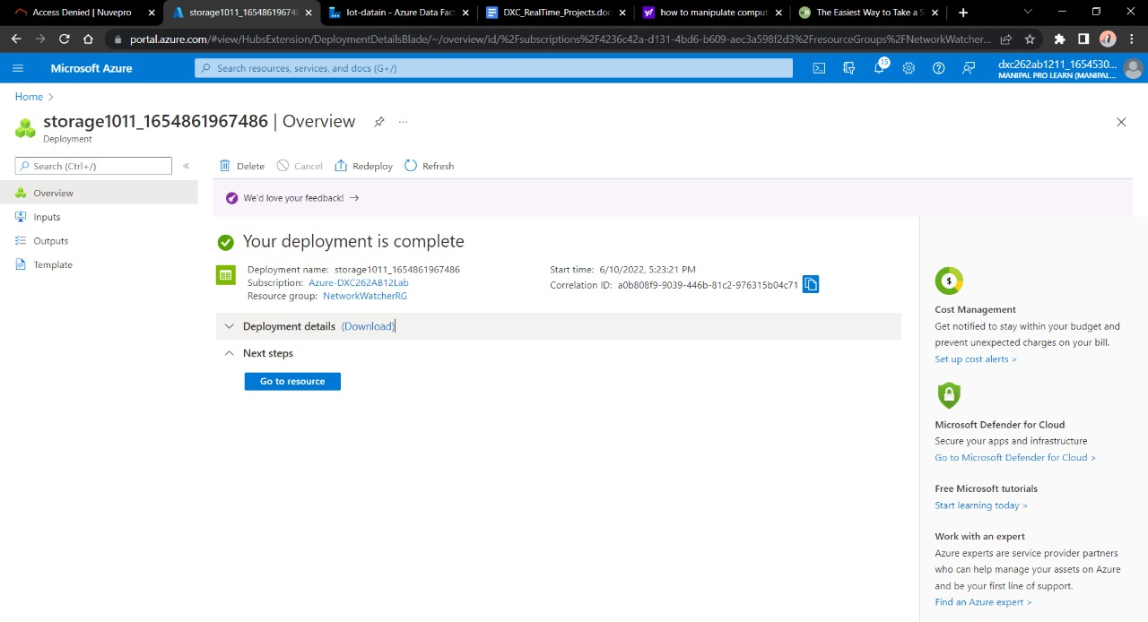

STEP-5

Click on Containers on the left side . Click on *+ Container*.

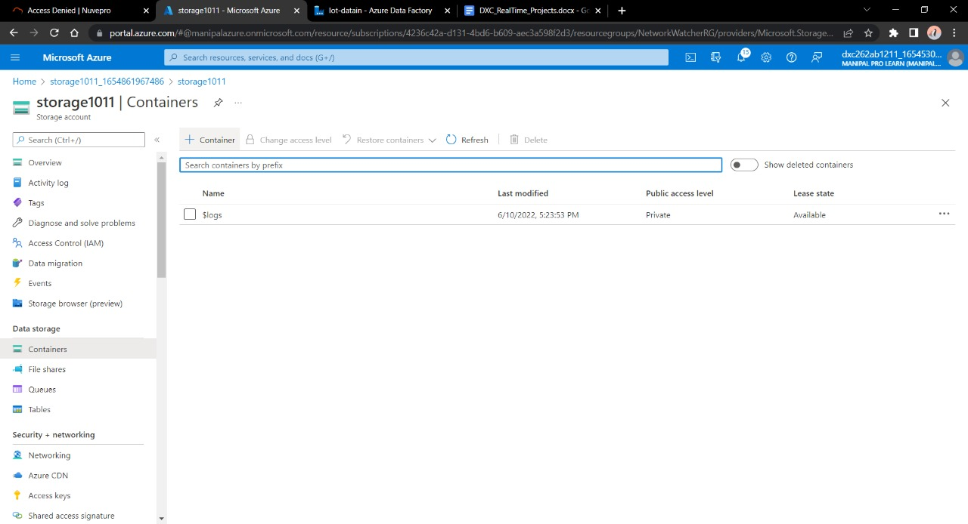

Fill in the necessary details of the container. Click create.

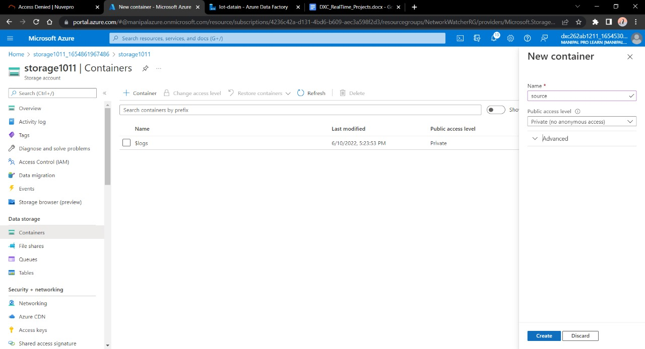

After creating a container called ‘Source’ , click on it. Click on upload.

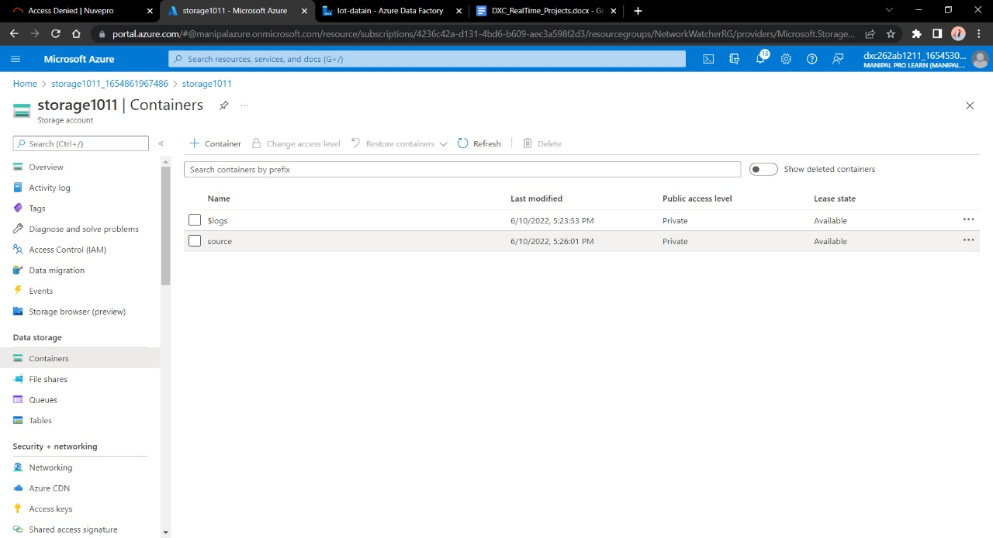

After that , input the data file in the Source . Do required settings and click Upload.

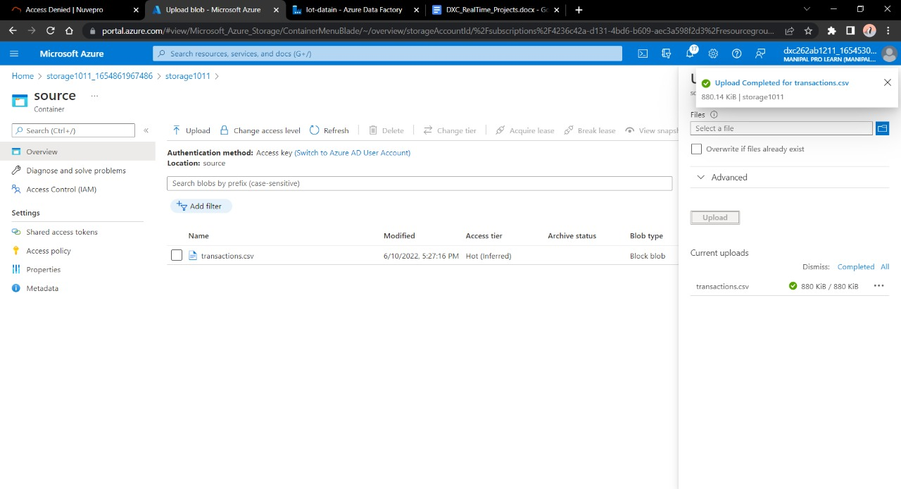

STEP-6

Go back to Home and click on or search **SQL DATABASES**.

Open it. Fill the necessary details and deploy it.

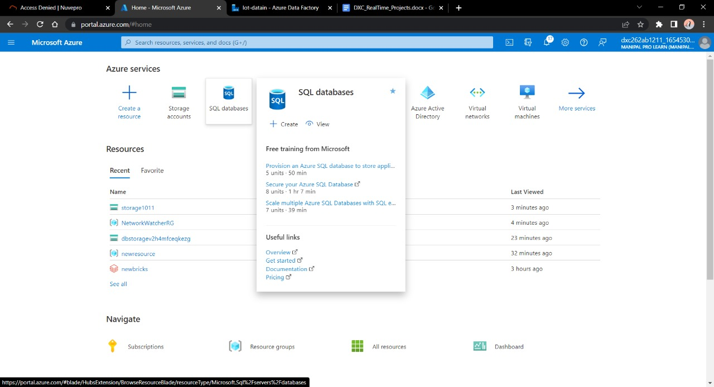

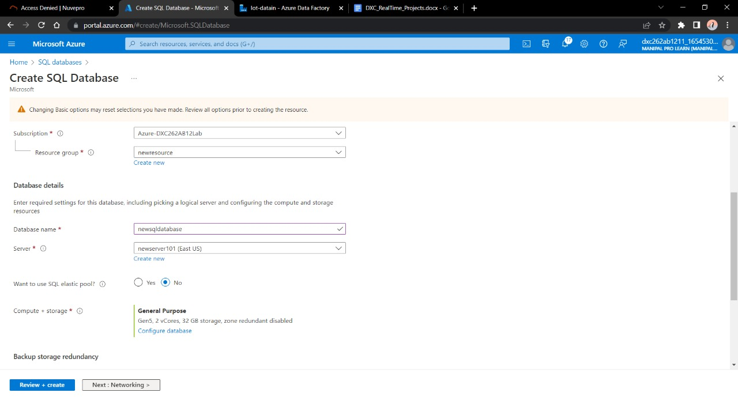

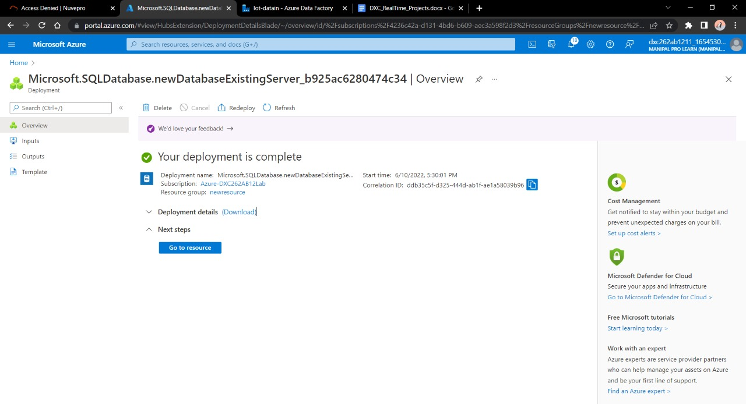

STEP - 7

After these steps come back to **Azure Data Factory Lab .**

Click on Ingest.

Click on Built-On-Copy Option.

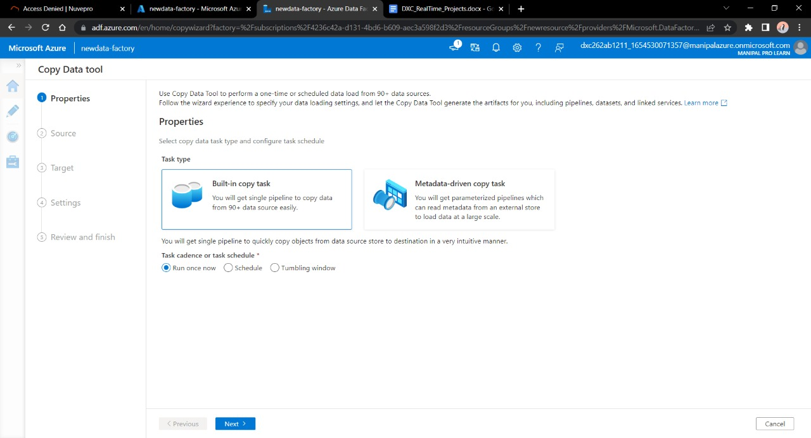

Enter the name of Azure blob storage linked file. Select the name of storage account name we created in this and click on Create.

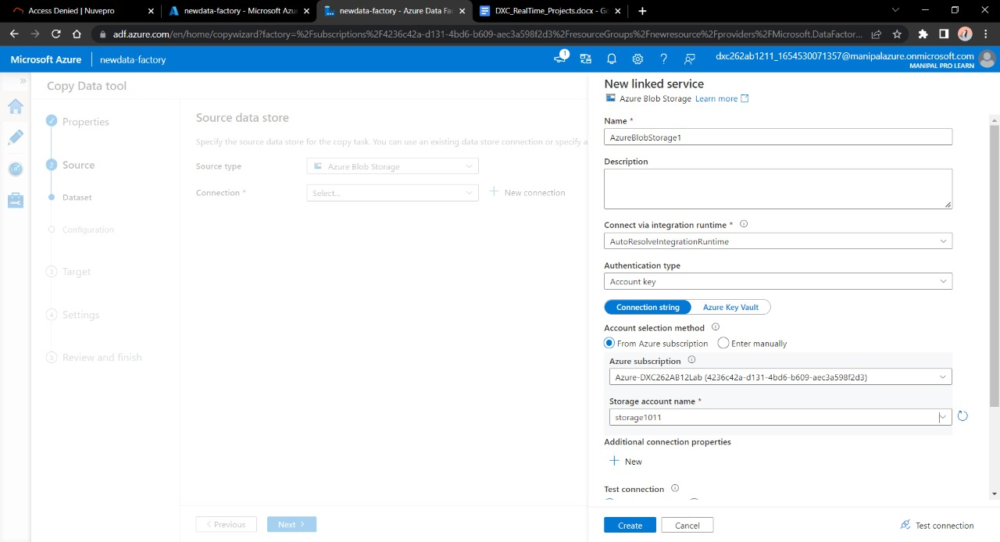

Select the source type as blob storage and connection name that we created in previous step. Click Recursively from Options. Click Next.

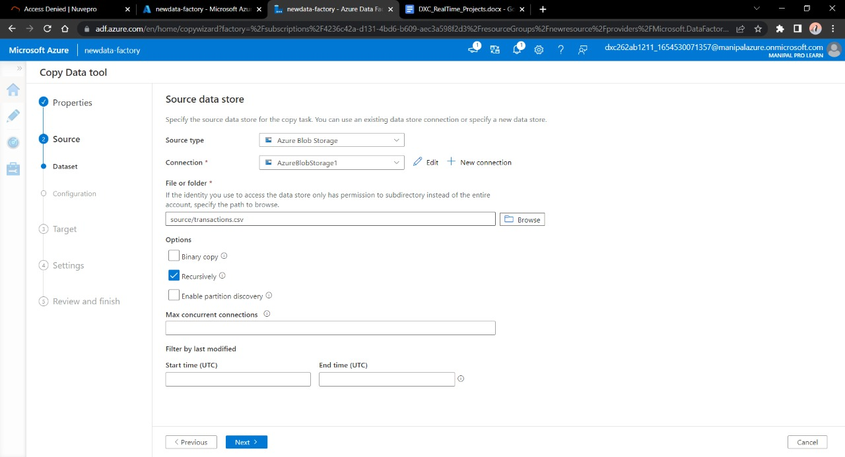

Select the file formatting settings as Delimited data , do following settings –

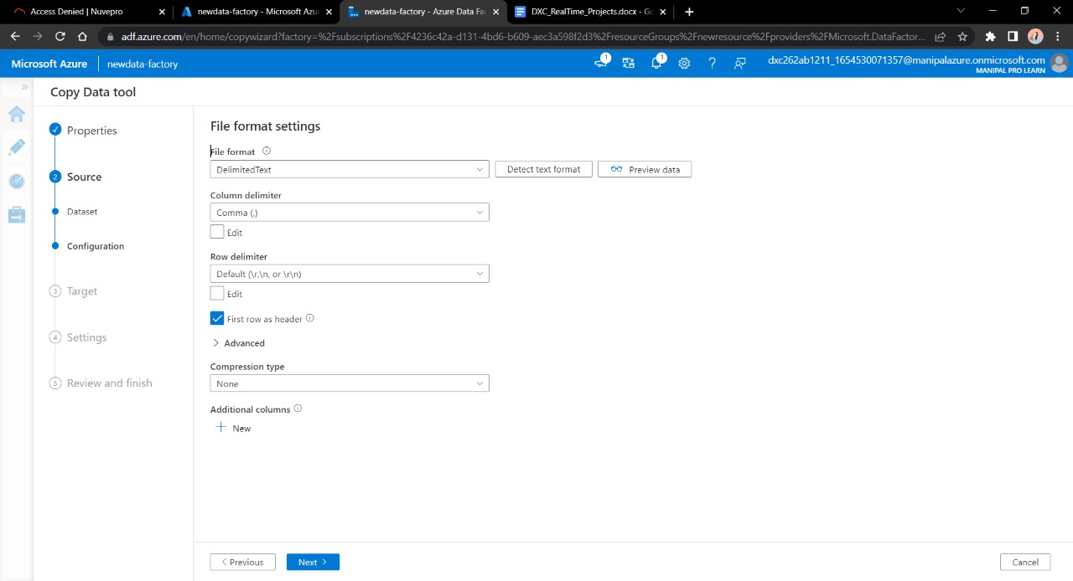

Now , in the next step we have to link this Data Factory with our SQL database we made earlier. Fill in the username and password used in SQL Database , click next.

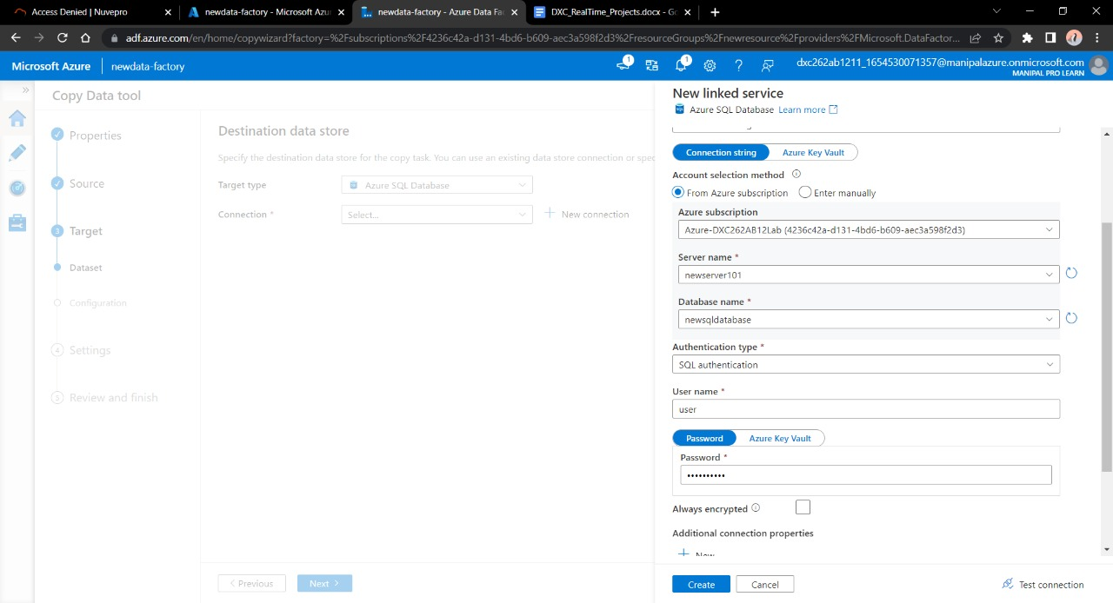

Now, to describe destination blob follow the same steps as we did to create Source blob. Click Next.

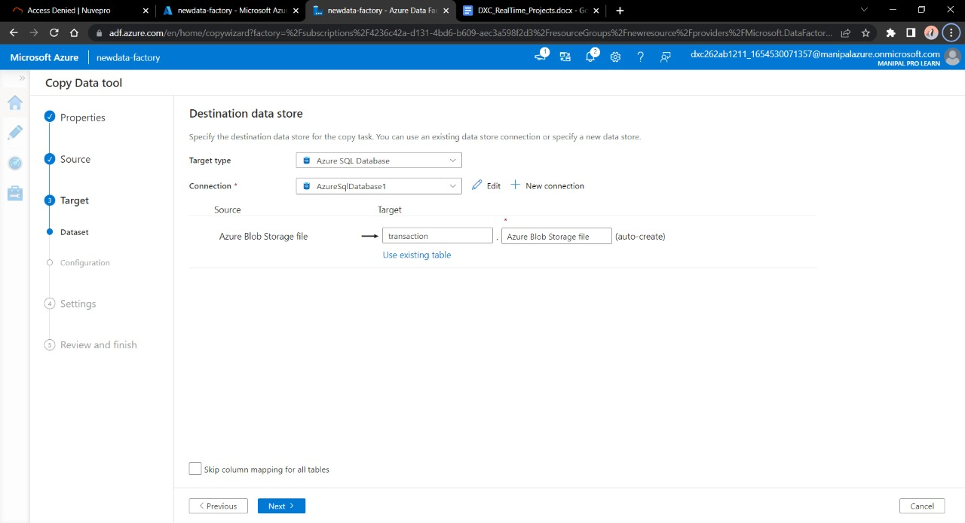

After making necessary configurations click next. In settings define task name , click next.

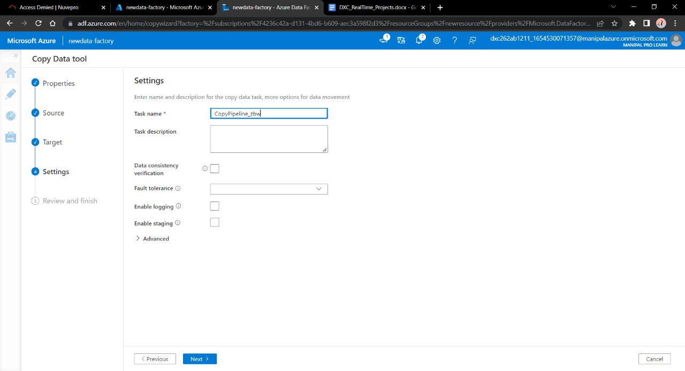

Following page will appear. Click Next.

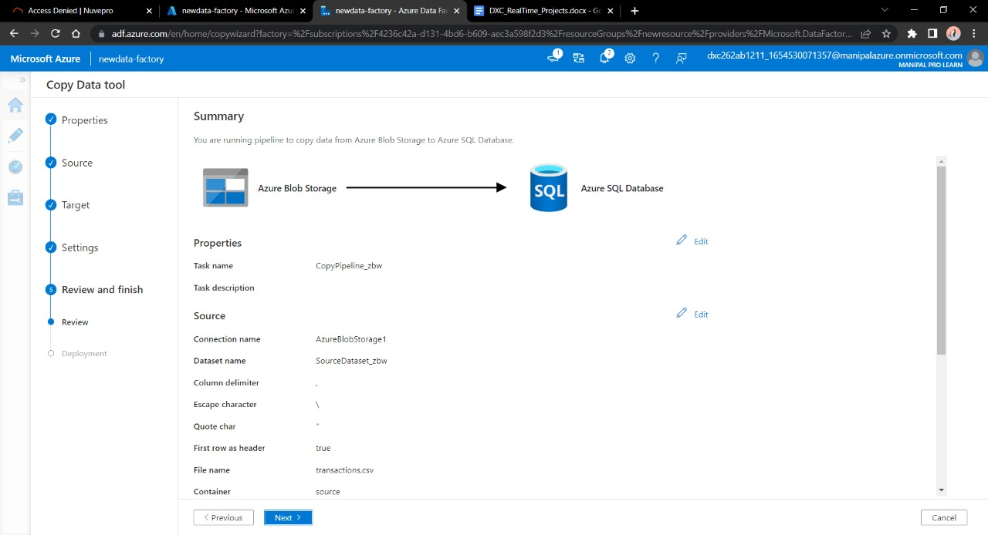

Create the pipeline from Pipeline option. Enter the data asked in instructions and trigger the pipeline.

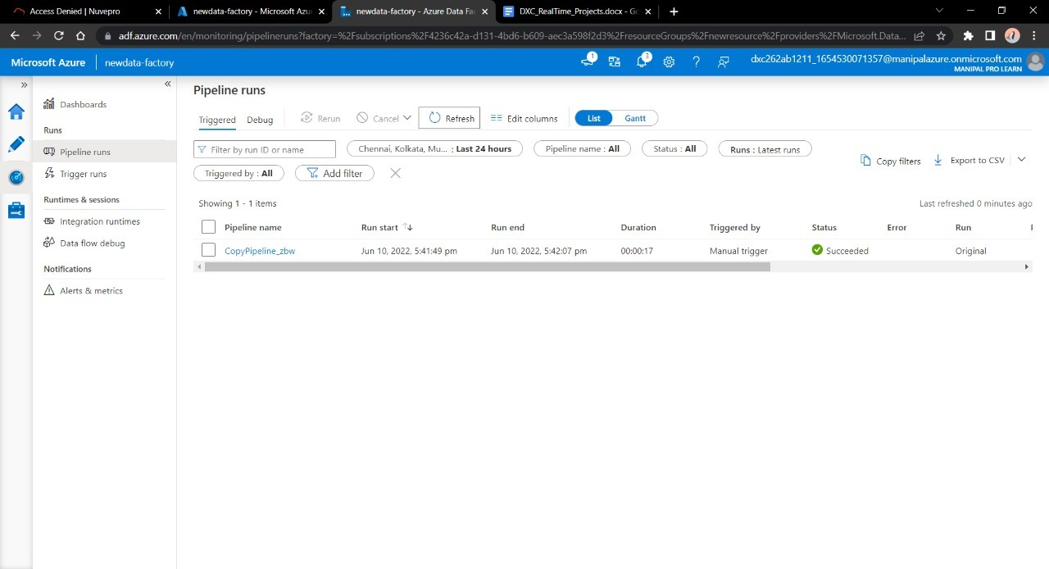

Direct the created pipeline towards SQL Database we configured earlier.

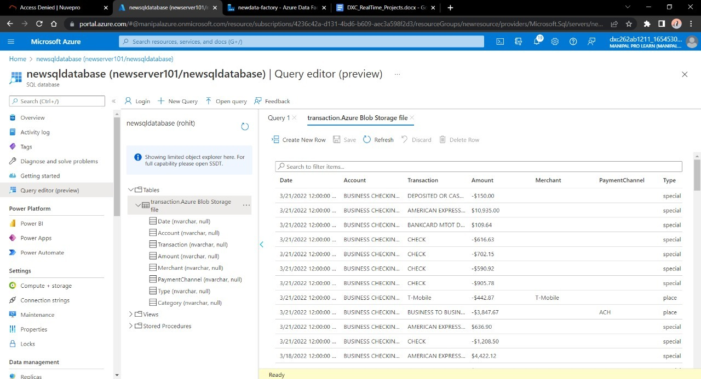

**Result:** We were able to connect our blob data into SQL Database via pipeline using Azure DF.

**Conclusion:** The data is successfully stored in SQL DATABASE.

PROJECT - 2

Name: Aakriti Singh

Reg No: DXC262AB12002

**Project2 Name: AP Morgan Data Platform**

Date: 11th June , 2022

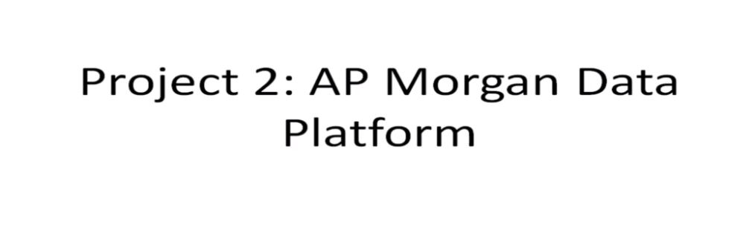

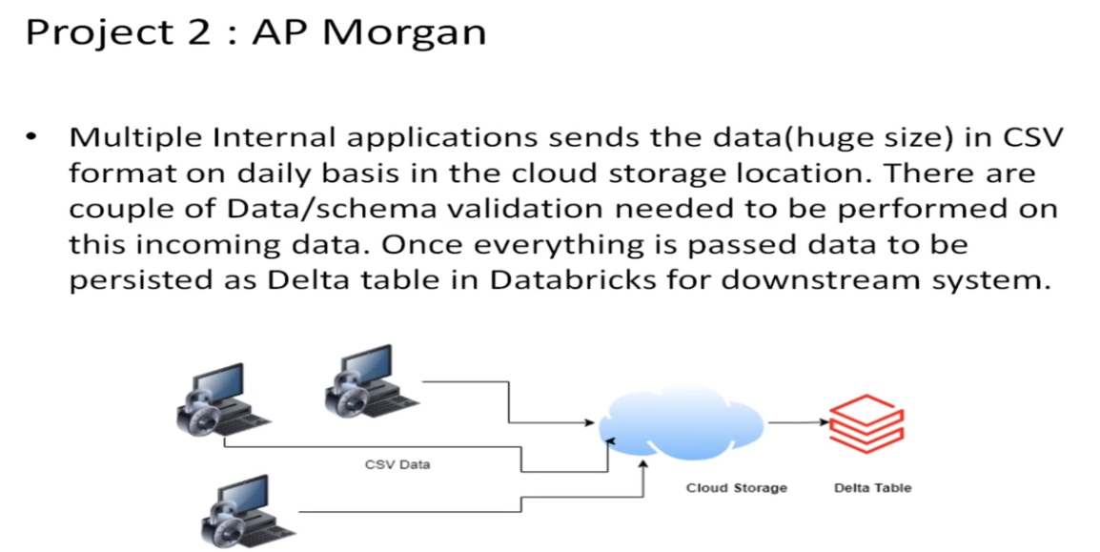

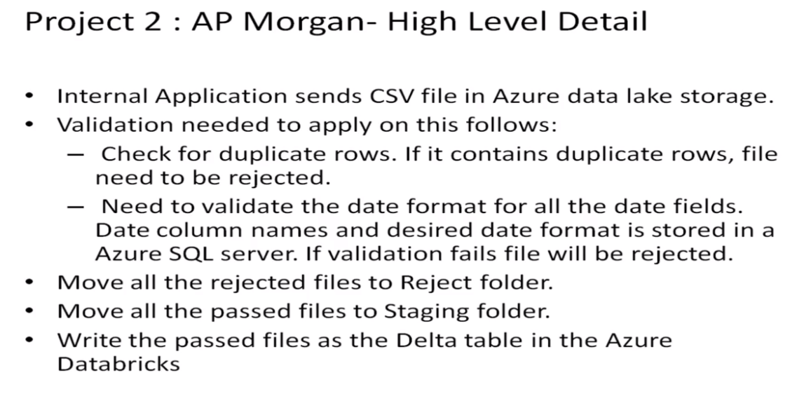

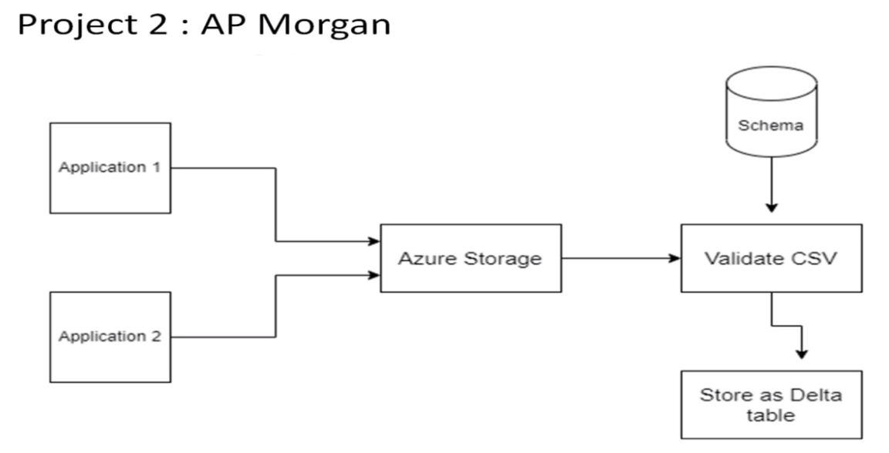

**STEP-1** –

Open Microsoft Azure Lab. Create the Data Factory account just like specified in first project.

After this, come back at home and and create Data Bricks account.

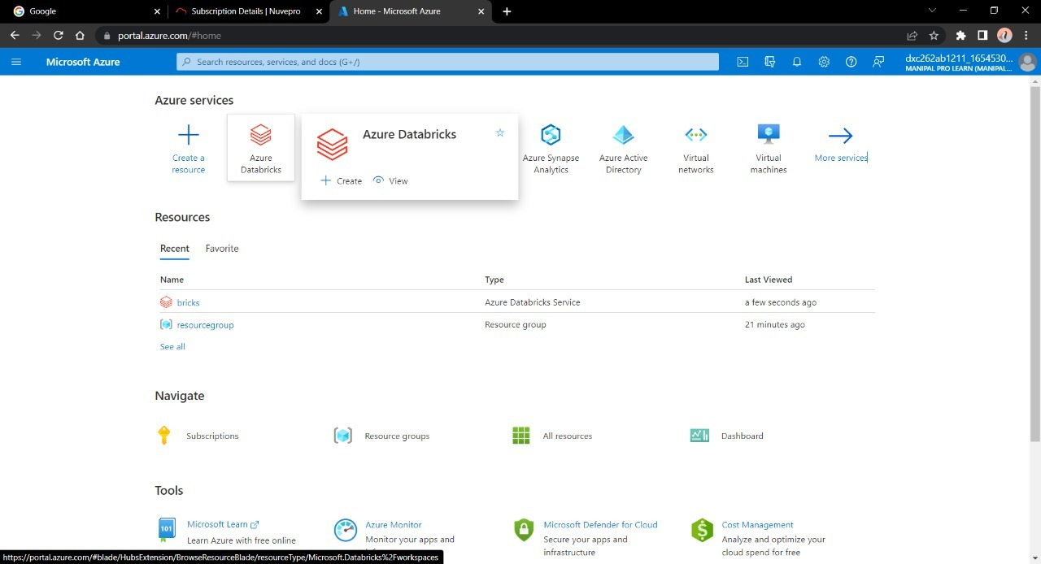

**STEP-2** –

While making Data Bricks account , give yes for formation of cluster since this will be used afterwards.

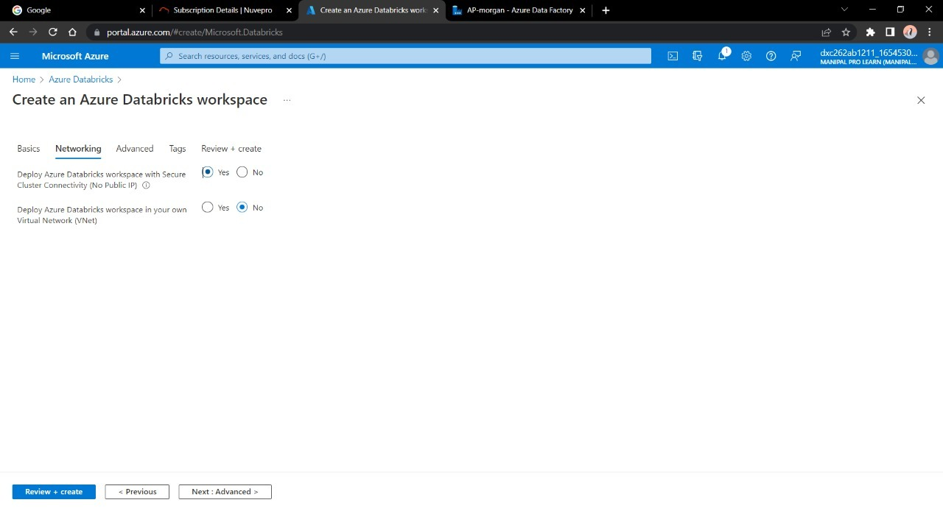

After successful deployment of the account , click go to resource, then following screen will appear –

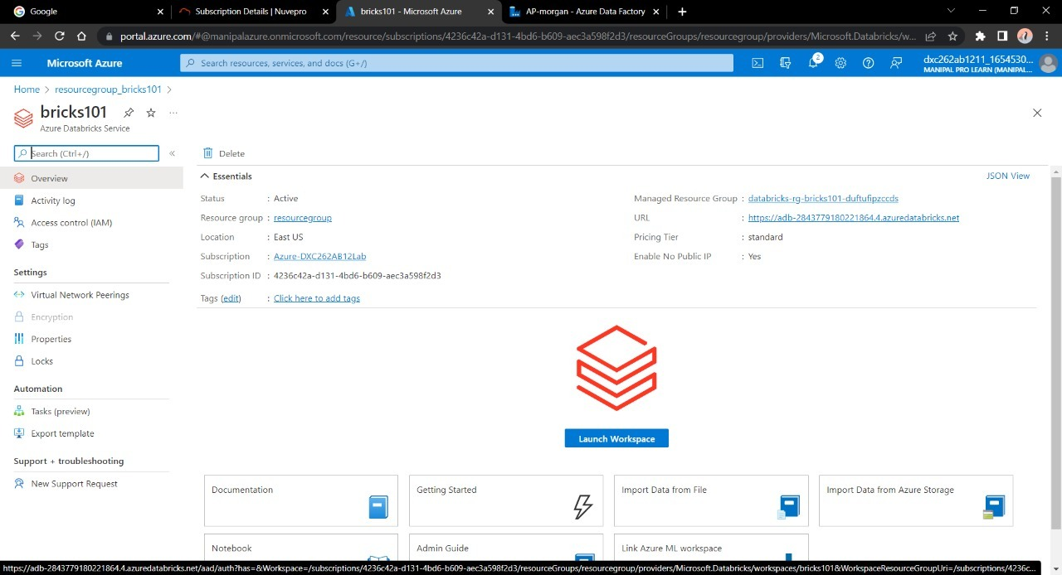

Click on **Launch Workspace**. Wait and sign in .

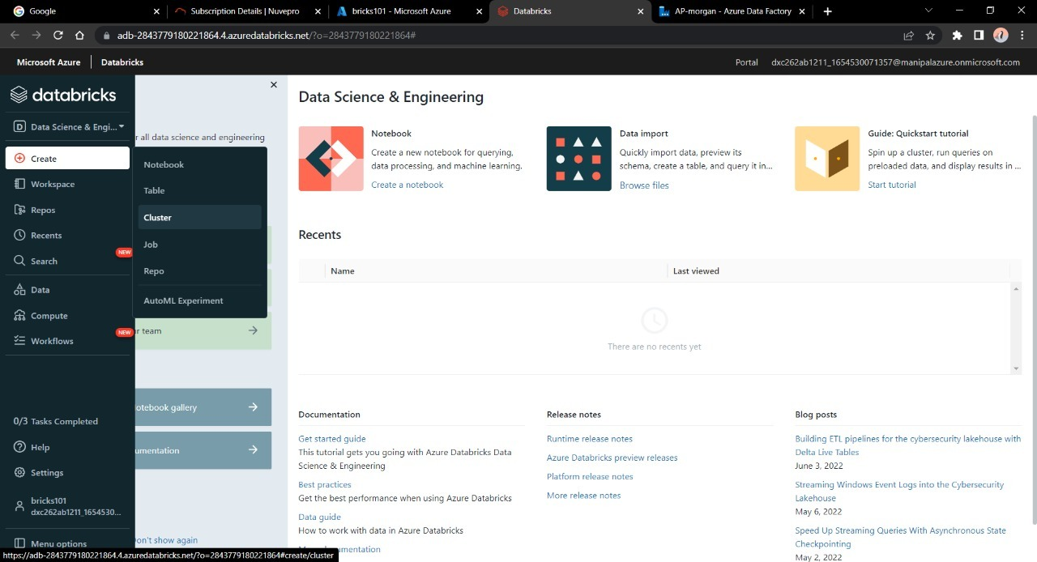

**STEP-3** –

Click on Create . Click on Cluster since we need to create a cluster first.

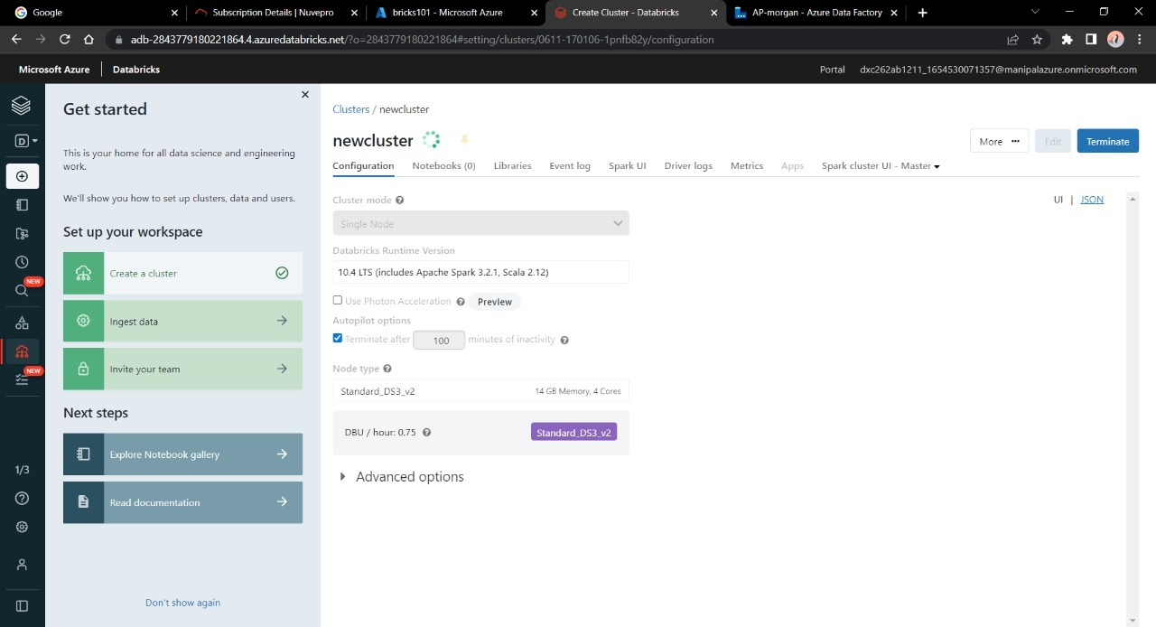

Select the mode as SINGLE NODE, value of 100 to 30 and click on Create.

**STEP-4**

After the new cluster is made , we need a editor or a notebook to edit the data coming in data-bricks according to our requirements.

Click on Create🡪Notebook.

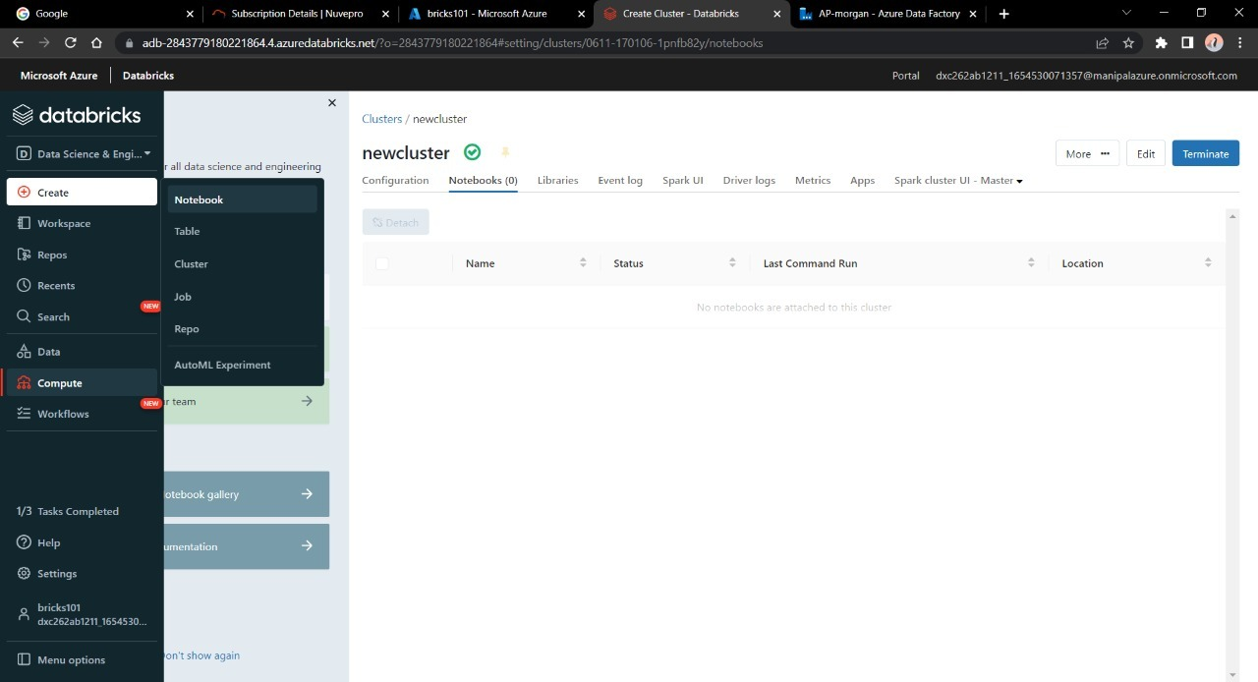

We can do some calculations , perform changes in data by importing data into the notebook via **DATA** option at home.

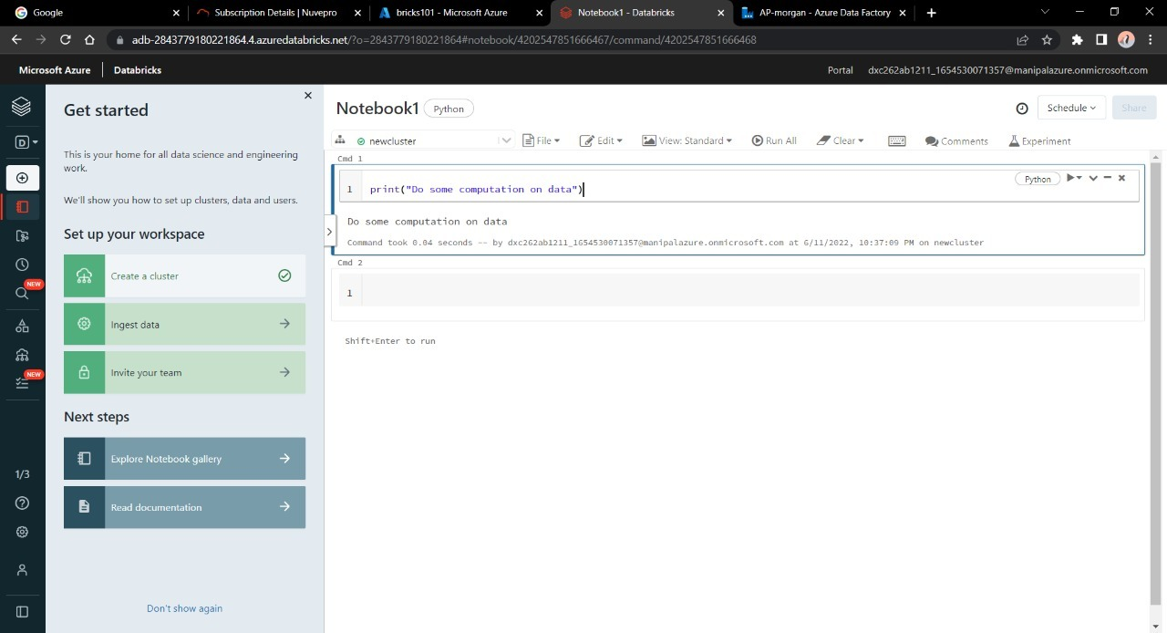

We then have to connect Notebook into Azure DF.

Deploy the Data Factory Account as mentioned in ***Project-1.***

**STEP-5**

Open Data Factory lab and click on **Azure Data Factory Studio.**

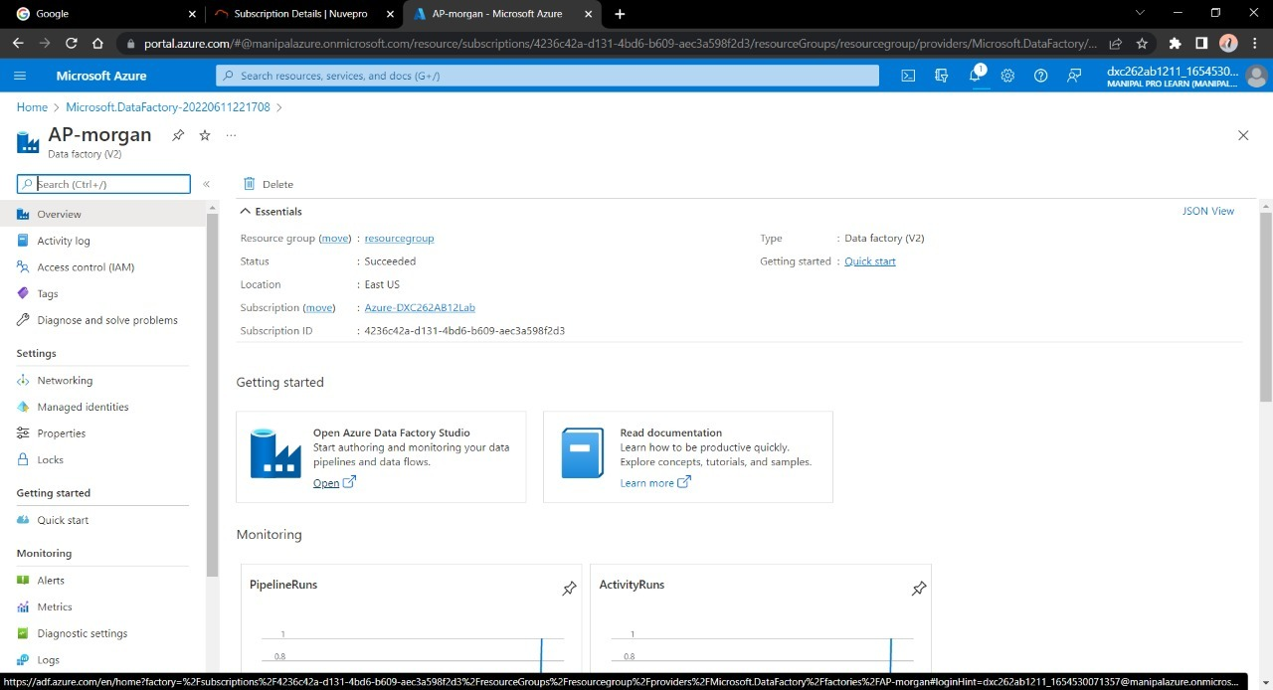

Construct a Pipeline to connect Data-Bricks Notebook to DF.

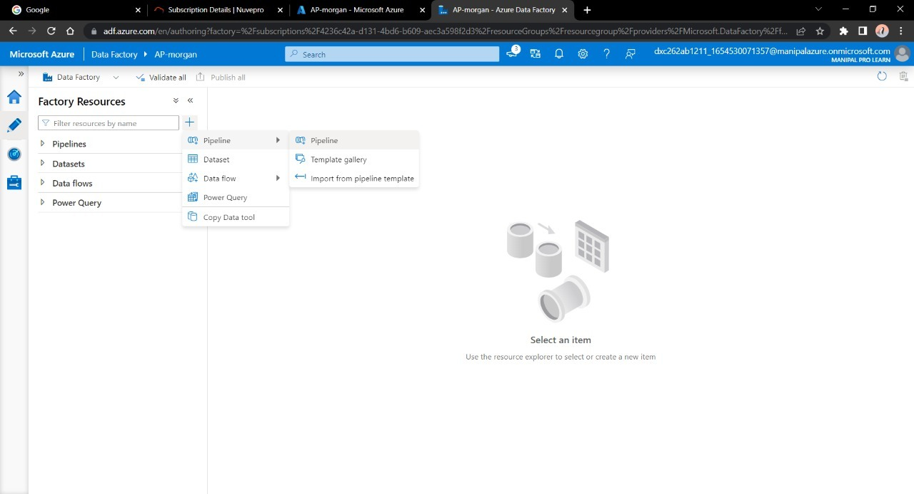

Drag and drop notebook tab into pipeline workspace.

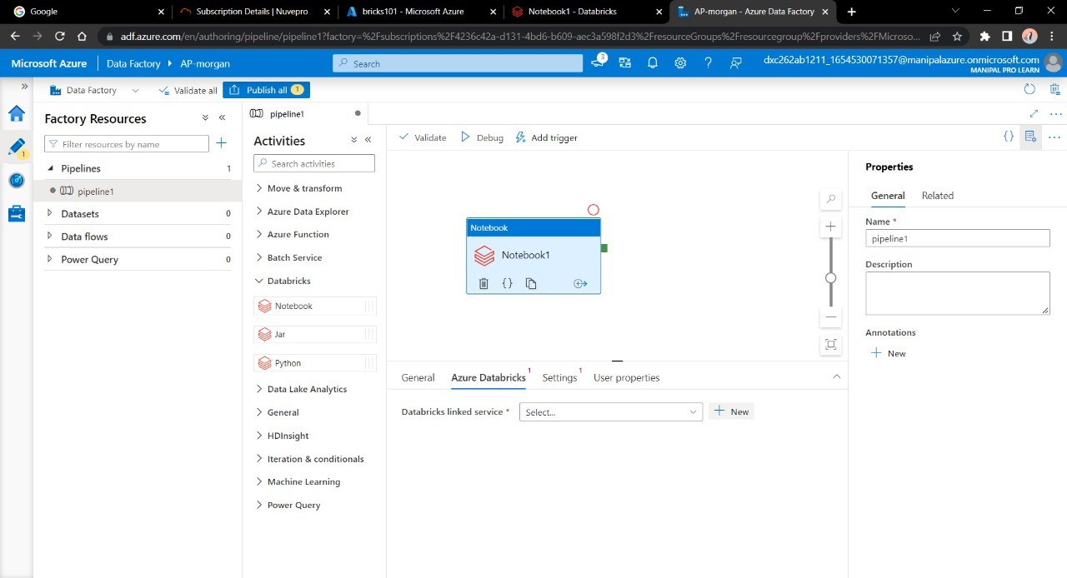

Click on new linked service , fill necessary data. Enter the cluster name in cluster ID . We need a token code to link both services.

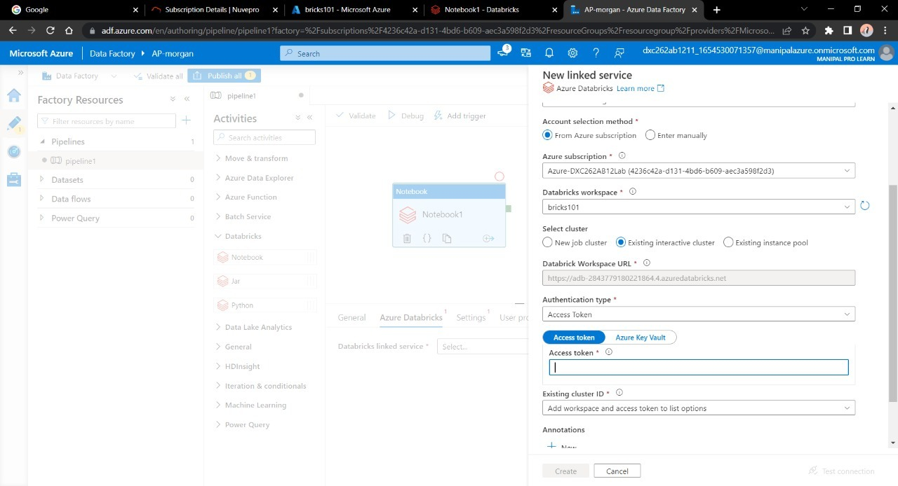

**STEP-6**

Go to data-bricks home, click on users 🡪 User Settings. Click on Generate Token. Copy the token on a Notepad.

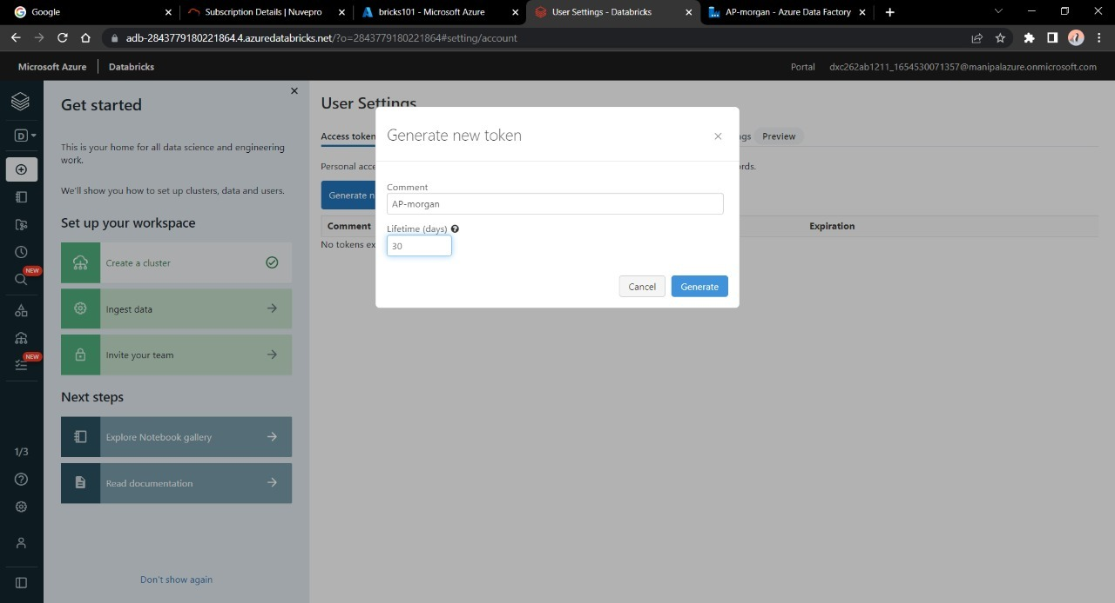

After this , go back to DF Link Configuration , paste the token from Notepad to it. Click Create.

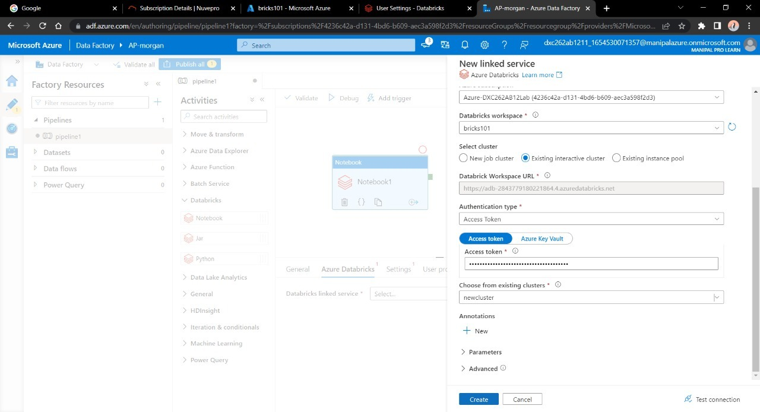

Now choose notebook from pipeline option to trigger it into Data Factory. Click OK.

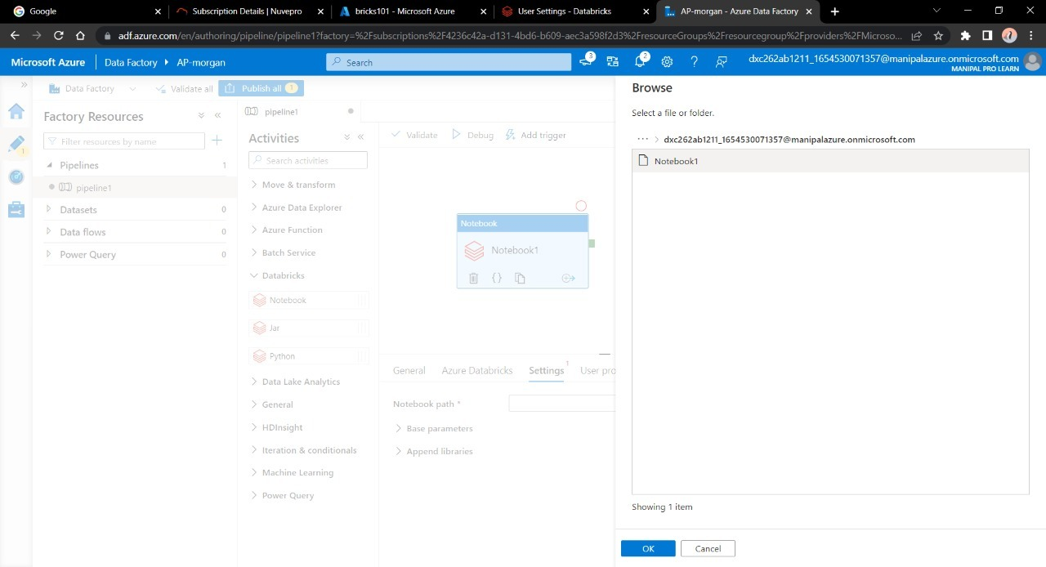

Click on Publish Now 🡪 Trigger Now.

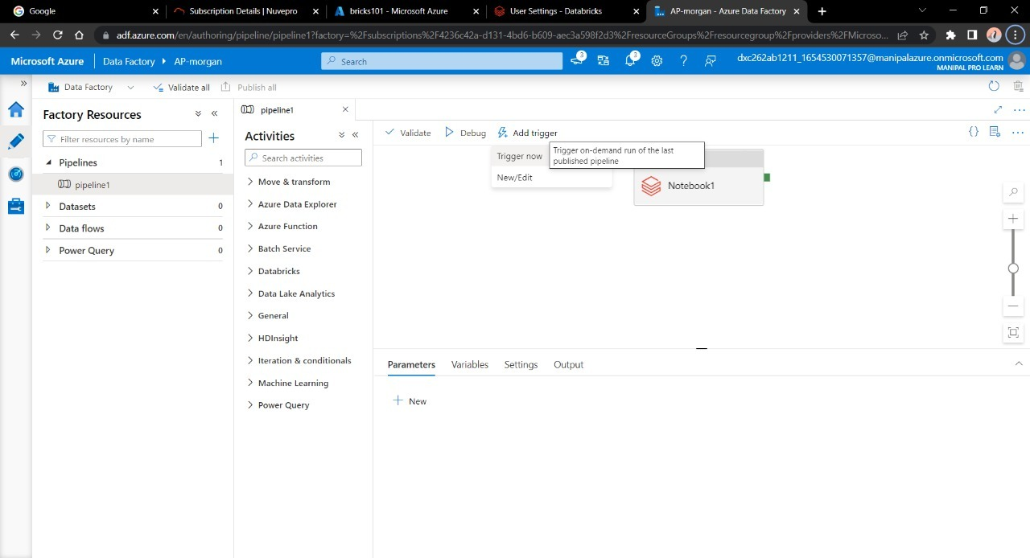

Navigate to Monitor option and check the execution .

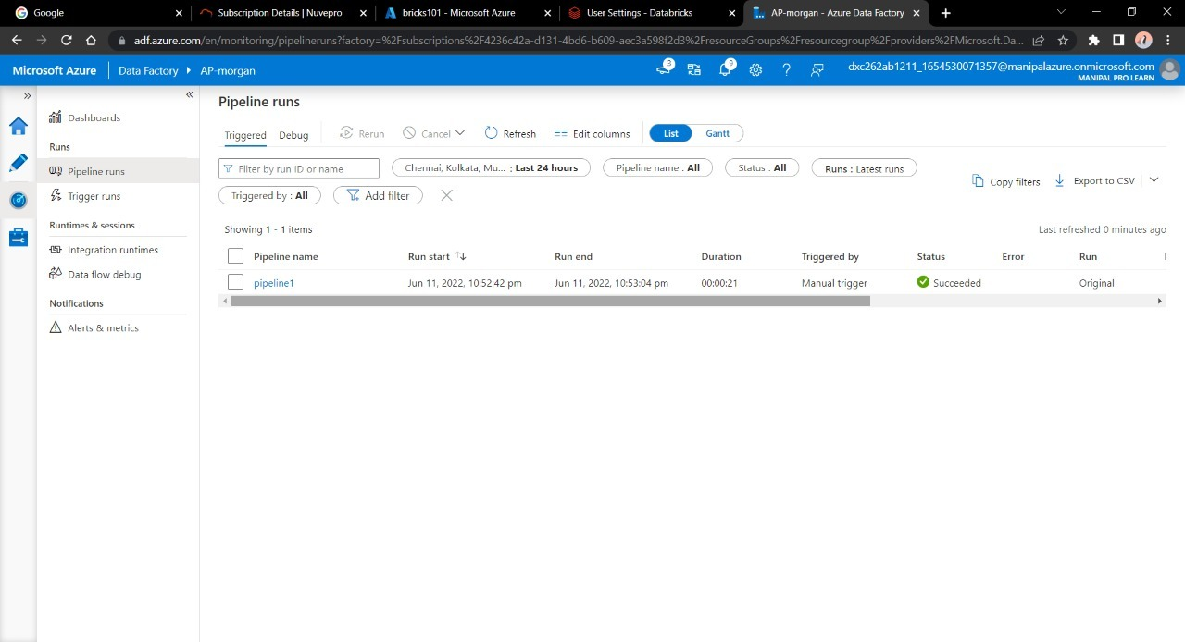

**Result:** Were able to link and trigger Azure Data Bricks Notebook via Data Factory.

**Conclusion:** Successful in connecting Azure DB with Azure DF.